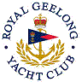 | Royal Geelong Yacht Club Inc.  Est 1859
Trophy Deed of Gift.

Trophy: | Tasman II Trophy
Presented by: | Frank Heyward
Date: | 1970
For: | Cadet Class: Championship Runner-Up
Remarks / Revisions | In memory of Ross (son)
Click here for a List of Recipients

